insurance_claims | SBP
V1.0

Revision History
Version | Date | Description | Author
1.0 | 17/02/2026 | Initial Version | Mohammed Megahed

Reviewers
# | Name | Position | Date and Signature
1
2

Acceptance and Signoff
# | Name | Position | Date and Signature
1
2

Contents
1. Introduction 5
1.1. Project Summary 5
1.2. In-Scope 5
1.3. Out-Scope 5
1.4. Target Audience 5
1.5. Abbreviations 5
1.6. Assumptions, Dependencies and Risks 6
1.7. Impact Questionnaire 6
2. Requirements Compliancy Matrix 6
3. Solution Architecture 7
3.1. Solution Description 7
3.2. Non-Functional Requirements 8
3.3. Security Considerations 8
4. Motor Insurance Claim Submission 9
4.1. Sequence Diagram 9
4.2. Flow Description 10
4.3. State Machine Diagram 13
4.4. APIs Contract Agreement 14
4.5. Error Handling 15
5. Claim Adjudication and Settlement 18
5.1. Sequence Diagram 18
5.2. Flow Description 19
5.3. State Machine Diagram 22
5.4. APIs Contract Agreement 23
5.5. Error Handling 25
6. Appendix 28
6.1. Motor Insurance Claim Submission Data Elements 28
6.2. Claim Adjudication and Settlement Data Elements 29
6.3. Solution Architecture Reference Documents 30

1. Introduction

1.1. Project Summary
We are building a digital claims management platform for motor insurance that enables customers to submit First Notice of Loss via a mobile app, addressing delays and inefficiencies in traditional claims processes. Key features include photo and video capture for damage documentation, AI-driven damage assessment and cost estimation, automated claim routing, and integrated fraud detection. This solution reduces claim processing time and improves accuracy for both customers and claims teams.

1.2. In-Scope
# | Item
1. | First Notice of Loss (FNOL) via mobile app
2. | Photo and video capture for damage documentation
3. | AI-based damage assessment and cost estimation
4. | Automated claim routing and assignment
5. | Fraud scoring and detection
6. | Settlement offer generation
7. | Direct payment to repair shops or customers

1.3. Out-Scope
# | Item
1. | Policy administration and underwriting
2. | Reinsurance management
3. | Litigation and subrogation
4. | Third-party liability claims

1.4. Target Audience
# | Stakeholders
1. | Enterprise Architects
2. | Partners and Vendors Technical Leaders
3. | Infrastructure Architects & Engineers
4. | InfoSec Architects & Engineers
5. | Technical Managers
6. | Delivery Leads and Project Managers
7. | Developers

1.5. Abbreviations
# | Abbreviations | Full form
1

1.6. Assumptions, Dependencies and Risks
# | Item | Type | Owner | Comment
1.
2.

2. Requirements Compliancy Matrix
ID. | Title | Description | Compliancy | Comments
FR-1 | ClaimsPro is a digital-first insurance claims management platform for motor, hea | ClaimsPro provides a streamlined digital platform for managing motor, health, and property insurance claims, enabling faster processing and improved customer experience. | Compliant
FR-2 | AI-powered damage assessment and automated adjudication enable faster claim proc | The solution uses AI to assess damage and automate claim decisions, allowing customers to receive faster claim resolutions and improving overall claims processing efficiency. | Compliant
FR-3 | Integration with repair networks enables direct settlement with service provider | The business enables direct payment to service providers by integrating with repair networks, streamlining the settlement process and improving efficiency for all parties involved. | Compliant
FR-BR-001 | ubmission | Users can submit a First Notice of Loss (FNOL) to report an incident or claim, ensuring timely notification and initiation of the claims process. | Compliant
FR-BR-002 | Photo Capture | Users can capture photos to provide visual evidence for compliance, verification, or record-keeping purposes. | Compliant
FR-BR-003 | ssessment | The organization conducts regular assessments of AI systems to ensure they align with business objectives, comply with relevant regulations, and manage risks effectively. | Compliant
FR-BR-004 | Cost Estimation | Provide accurate cost estimates to support informed decision-making and effective budget planning. | Compliant
FR-BR-005 | Claim Routing | Claims are directed to the appropriate team or individual to ensure timely and accurate processing. This supports efficient workflow and improves customer service. | Compliant
FR-BR-006 | Fraud Scoring | The system assigns a fraud risk score to each transaction to help identify and prevent potential fraudulent activity. This enables the business to take appropriate action to reduce financial losses and protect customers. | Compliant
FR-BR-007 | Auto-Adjudication | The system automatically reviews and processes claims according to predefined rules, reducing manual intervention and ensuring timely, consistent outcomes for users. | Compliant
FR-BR-008 | Settlement Offer | The business provides customers with a clear settlement offer to resolve outstanding balances, ensuring transparency and supporting fair financial resolution. | Compliant
FR-BR-009 | Direct Payment | The organization enables customers to make payments directly, ensuring a simple and efficient transaction process. This supports timely settlement of accounts and improves customer satisfaction by offering a straightforward payment option. | Compliant
FR-BR-010 | Claim Tracking | The business tracks the status and progress of all claims to ensure timely resolution and provide visibility to stakeholders. | Compliant

3. Solution Architecture

3.1. Solution Description
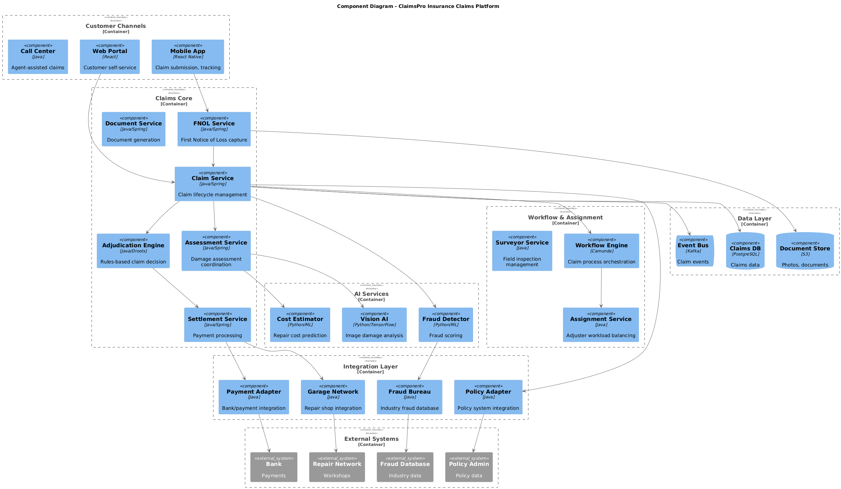

3.2. Non-Functional Requirements
# | Category | Requirement | Target/SLA
1 | Performance | API Response Time | < 2 seconds for 95th percentile
2 | Performance | Transaction Throughput | Support 100 TPS during peak hours
3 | Availability | System Uptime | 99.9% availability (excluding planned maintenance)
4 | Availability | Recovery Time Objective (RTO) | < 4 hours
5 | Availability | Recovery Point Objective (RPO) | < 1 hour
6 | Scalability | Horizontal Scaling | Support auto-scaling based on load
7 | Scalability | Concurrent Users | Support 1000 concurrent users
8 | Data Retention | Transaction Logs | Retain for 7 years as per regulatory requirements
9 | Data Retention | Audit Logs | Retain for 5 years
10 | Compliance | Regulatory | Comply with CMA and SAMA regulations
11 | Compliance | Data Protection | Comply with data privacy requirements

3.3. Security Considerations
# | Security Domain | Requirement | Implementation
1 | Authentication | User Authentication | OAuth 2.0 / JWT tokens with secure token storage
2 | Authentication | Service-to-Service Auth | Mutual TLS (mTLS) for internal service communication
3 | Authentication | Multi-Factor Authentication | MFA required for sensitive operations
4 | Authorization | Role-Based Access Control | RBAC implemented with principle of least privilege
5 | Authorization | API Authorization | Scope-based access control for API endpoints
6 | Data Protection | Data in Transit | TLS 1.2+ encryption for all network communication
7 | Data Protection | Data at Rest | AES-256 encryption for sensitive data storage
8 | Data Protection | PII/Sensitive Data | Data masking and tokenization for sensitive fields
9 | API Security | Input Validation | Server-side validation of all input parameters
10 | API Security | Rate Limiting | Rate limiting to prevent abuse and DDoS attacks
11 | API Security | CORS Policy | Strict CORS policy for web API endpoints
12 | Audit & Logging | Audit Trail | Log all security-relevant events with timestamps
13 | Audit & Logging | Log Protection | Immutable logs with tamper detection
14 | Vulnerability Management | Security Scanning | Regular SAST/DAST scanning in CI/CD pipeline
15 | Vulnerability Management | Dependency Scanning | Automated scanning for vulnerable dependencies

4. Motor Insurance Claim Submission

4.1. Sequence Diagram
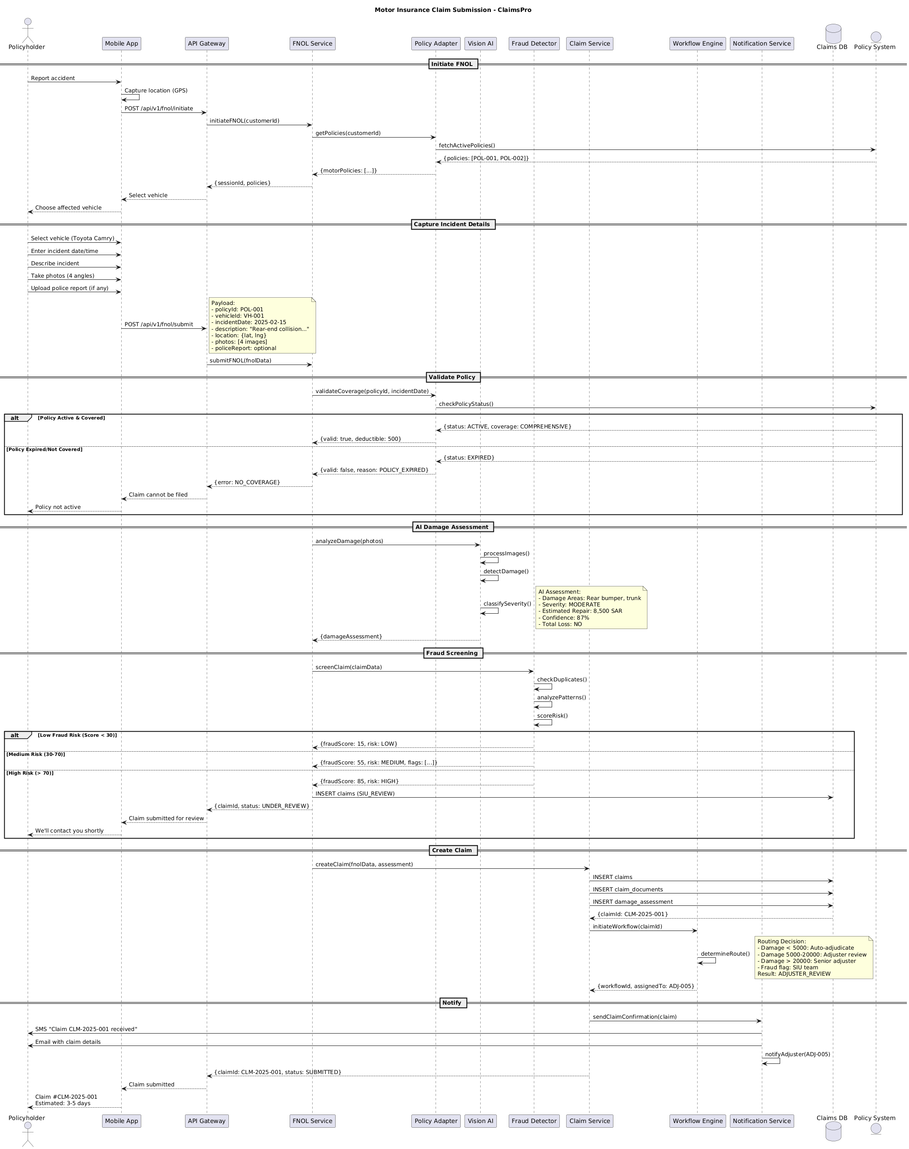

4.2. Flow Description
  - Overview
This flow describes the end-to-end process for submitting a motor insurance claim using the ClaimsPro platform. The process involves several actors and systems, including Policyholder, Mobile App, API Gateway, FNOL Service, Policy Adapter, Policy System, Vision AI, Fraud Detector, Claim Service, Workflow Engine, Notification Service, and Claims DB. Each participant is responsible for specific interactions, validations, assessments, and notifications throughout the claim submission lifecycle.
  - Process Flow
Initiate FNOL
The process begins when Policyholder reports an accident using Mobile App. Mobile App internally captures the location. Mobile App sends a request to API Gateway to initiate the First Notice of Loss process. API Gateway forwards this request to FNOL Service, which then requests Policy Adapter to retrieve all policies associated with the customer. Policy Adapter queries Policy System to fetch active policies. Policy System responds with a list of policies, which Policy Adapter returns to FNOL Service as a filtered set of motor policies. FNOL Service provides API Gateway with a session identifier and the available policies. API Gateway prompts Mobile App to let the customer select the affected vehicle. Mobile App then asks Policyholder to choose the affected vehicle.
Capture Incident Details
Policyholder interacts with Mobile App to select the vehicle (e.g., Toyota Camry), enter the incident date and time, describe the incident, take photos from four angles, and upload a police report if available. Mobile App submits these details to API Gateway.
Note: Payload:
- policyId: POL-001
- vehicleId: VH-001
- incidentDate: 2025-02-15
- description: "Rear-end collision..."
- location: {lat, lng}
- photos: [4 images]
- policeReport: optional
API Gateway forwards the FNOL submission to FNOL Service for further processing.
Validate Policy
FNOL Service requests Policy Adapter to validate coverage for the selected policy and incident date. Policy Adapter queries Policy System to check the policy status.
If the policy is active and covered, Policy System responds with an active status and coverage details. Policy Adapter returns a valid policy response, including deductible information, to FNOL Service.
If the policy is expired or not covered, Policy System responds with an expired status. Policy Adapter returns an invalid policy response with the reason for rejection to FNOL Service. FNOL Service notifies API Gateway of the lack of coverage, which in turn informs Mobile App that the claim cannot be filed. Mobile App notifies Policyholder that the policy is not active.
AI Damage Assessment
FNOL Service sends the submitted photos to Vision AI for automated damage analysis. Vision AI internally processes the images. Vision AI performs an internal operation to detect damage. Vision AI internally classifies the severity of the damage.
Note: AI Assessment:
- Damage Areas: Rear bumper, trunk
- Severity: MODERATE
- Estimated Repair: 8,500 SAR
- Confidence: 87%
- Total Loss: NO
Vision AI returns the damage assessment results to FNOL Service.
Fraud Screening
FNOL Service sends the claim data to Fraud Detector for fraud screening. Fraud Detector internally checks for duplicate claims. Fraud Detector internally analyzes claim patterns. Fraud Detector internally scores the risk associated with the claim.
If the fraud risk is low (score less than 30), Fraud Detector returns a low-risk assessment to FNOL Service.
If the fraud risk is medium (score between 30 and 70), Fraud Detector returns a medium-risk assessment with relevant flags to FNOL Service.
If the fraud risk is high (score greater than 70), Fraud Detector returns a high-risk assessment to FNOL Service. FNOL Service inserts the claim into Claims DB with a status indicating Special Investigation Unit review. FNOL Service notifies API Gateway that the claim is under review. API Gateway informs Mobile App that the claim has been submitted for review. Mobile App notifies Policyholder that they will be contacted shortly.
Create Claim
FNOL Service requests Claim Service to create a new claim using the FNOL data and the AI assessment. Claim Service inserts the claim record, claim documents, and damage assessment into Claims DB. Claims DB returns the new claim identifier to Claim Service. Claim Service initiates a workflow for the claim by contacting Workflow Engine. Workflow Engine internally determines the appropriate routing for the claim.
Note: Routing Decision:
- Damage < 5000: Auto-adjudicate
- Damage 5000-20000: Adjuster review
- Damage > 20000: Senior adjuster
- Fraud flag: SIU team
Result: ADJUSTER_REVIEW
Workflow Engine returns the workflow identifier and the assigned adjuster to Claim Service.
Notify
Claim Service instructs Notification Service to send a claim confirmation. Notification Service sends an SMS to Policyholder confirming receipt of the claim. Notification Service sends an email with claim details to Policyholder. Notification Service internally notifies the assigned adjuster. Claim Service provides API Gateway with the claim identifier and submission status. API Gateway informs Mobile App that the claim has been submitted. Mobile App notifies Policyholder of the claim number and provides an estimated processing time of three to five days.
  - Authentication & Validation
Each step in the process involves validation and verification by the respective systems. Policy validation ensures only active and covered policies proceed. AI-driven damage assessment and fraud screening add automated checks for claim legitimacy and risk. Internal operations, such as GPS capture, image processing, risk scoring, and workflow routing, are handled within the respective systems to maintain data integrity and process consistency.

4.3. State Machine Diagram
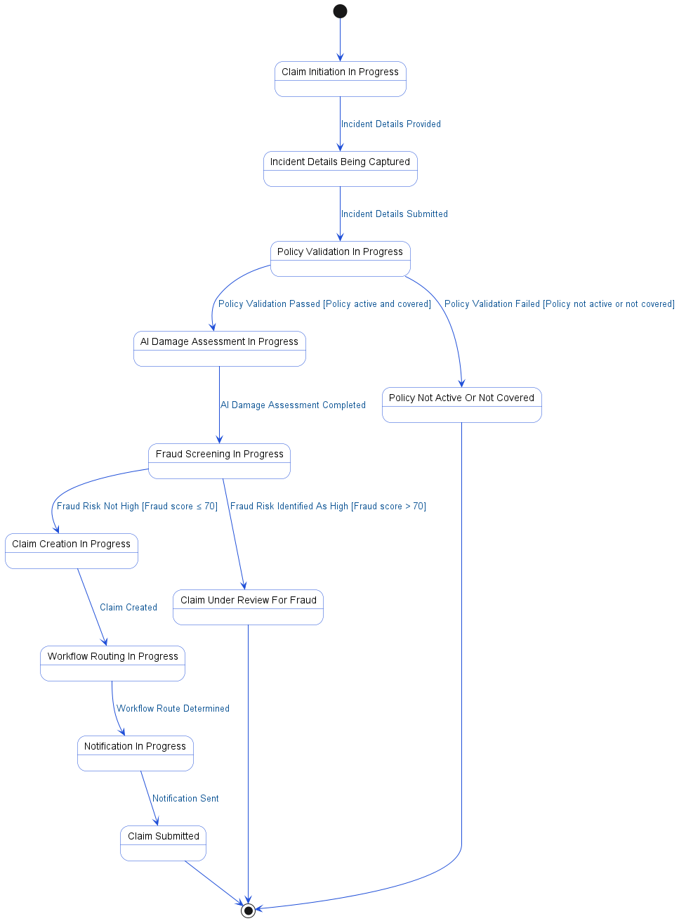

4.4. APIs Contract Agreement
# | Source | Destination | API | Protocol | Request Parameters | Response Parameters
1 | API Gateway | FNOL Service | initiateFNOL | REST | customerId | {sessionId, policies}
2 | FNOL Service | Policy Adapter | getPolicies | REST | customerId | {motorPolicies: [...]}
3 | Policy Adapter | Policy System | fetchActivePolicies | REST |  | {policies: [POL-001, POL-002]}
4 | API Gateway | FNOL Service | submitFNOL | REST | fnolData | {error: NO_COVERAGE}
5 | FNOL Service | Policy Adapter | validateCoverage | REST | policyId, incidentDate | {valid: true, deductible: 500}
6 | Policy Adapter | Policy System | checkPolicyStatus | REST |  | {status: ACTIVE, coverage: COMPREHENSIVE}
7 | FNOL Service | Vision AI | analyzeDamage | REST | photos | {damageAssessment}
8 | FNOL Service | Fraud Detector | screenClaim | REST | claimData | {fraudScore: 15, risk: LOW}
9 | FNOL Service | Claims DB | INSERT claims | JDBC | SIU_REVIEW
10 | FNOL Service | Claim Service | createClaim | REST | fnolData, assessment
11 | Claim Service | Claims DB | INSERT claims | JDBC |  | {claimId: CLM-2025-001}
12 | Claim Service | Claims DB | INSERT claim_documents | JDBC
13 | Claim Service | Claims DB | INSERT damage_assessment | JDBC
14 | Claim Service | Workflow Engine | initiateWorkflow | REST | claimId | {workflowId, assignedTo: ADJ-005}
15 | Claim Service | Notification Service | sendClaimConfirmation | REST | claim
16 | Notification Service | Policyholder | SMS "Claim CLM-2025-001 received" | REST
17 | Notification Service | Policyholder | Email with claim details | REST
[*] Indicates that the data element is optional

4.5. Error Handling
# | Source | Destination | Scenario | Handling
1 | API Gateway | FNOL Service | initiateFNOL  FNOL Service times out before responding | Retry up to 3 times with exponential backoff; Log error with correlation ID for traceability; Return error code to upstream caller
2 | API Gateway | FNOL Service | initiateFNOL  FNOL Service unavailable due to maintenance or crash | Retry up to 3 times with exponential backoff; Log error with correlation ID for traceability; Activate circuit breaker, use fallback response; Notify operations team via alert if repeated
3 | FNOL Service | Policy Adapter | getPolicies  Policy Adapter times out before responding | Retry up to 3 times with exponential backoff; Log error with correlation ID for traceability; Return error code to upstream caller
4 | FNOL Service | Policy Adapter | getPolicies  Policy Adapter unavailable due to outage | Retry up to 3 times with exponential backoff; Log error with correlation ID for traceability; Activate circuit breaker, use fallback response; Notify operations team via alert if repeated
5 | Policy Adapter | Policy System | fetchActivePolicies  Policy System times out before responding | Retry up to 3 times with exponential backoff; Log error with correlation ID for traceability; Return error code to upstream caller
6 | Policy Adapter | Policy System | fetchActivePolicies  Policy System unavailable due to maintenance | Retry up to 3 times with exponential backoff; Log error with correlation ID for traceability; Activate circuit breaker, use fallback response; Notify operations team via alert if repeated
7 | FNOL Service | Policy Adapter | validateCoverage  Policy Adapter times out before responding | Retry up to 3 times with exponential backoff; Log error with correlation ID for traceability; Return error code to upstream caller
8 | FNOL Service | Policy Adapter | validateCoverage  Policy Adapter unavailable due to outage | Retry up to 3 times with exponential backoff; Log error with correlation ID for traceability; Activate circuit breaker, use fallback response; Notify operations team via alert if repeated
9 | Policy Adapter | Policy System | checkPolicyStatus  Policy System times out before responding | Retry up to 3 times with exponential backoff; Log error with correlation ID for traceability; Return error code to upstream caller
10 | Policy Adapter | Policy System | checkPolicyStatus  Policy System unavailable due to maintenance | Retry up to 3 times with exponential backoff; Log error with correlation ID for traceability; Activate circuit breaker, use fallback response; Notify operations team via alert if repeated
11 | FNOL Service | Vision AI | analyzeDamage  Vision AI times out before responding | Retry up to 3 times with exponential backoff; Log error with correlation ID for traceability; Return error code to upstream caller
12 | FNOL Service | Vision AI | analyzeDamage  Vision AI unavailable due to system failure | Retry up to 3 times with exponential backoff; Log error with correlation ID for traceability; Activate circuit breaker, use fallback response; Notify operations team via alert if repeated
13 | FNOL Service | Fraud Detector | screenClaim  Fraud Detector times out before responding | Retry up to 3 times with exponential backoff; Log error with correlation ID for traceability; Return error code to upstream caller
14 | FNOL Service | Fraud Detector | screenClaim  Fraud Detector unavailable due to outage | Retry up to 3 times with exponential backoff; Log error with correlation ID for traceability; Activate circuit breaker, use fallback response; Notify operations team via alert if repeated
15 | FNOL Service | Claim Service | createClaim  Timeout before Claim Service responds | Ensure idempotency to avoid duplicates on retry; Retry up to 3 times with exponential backoff; Log error with correlation ID for traceability; Return error code to upstream caller
16 | FNOL Service | Claim Service | createClaim  Claim Service unavailable due to crash | Ensure idempotency to avoid duplicates on retry; Retry up to 3 times with exponential backoff; Log error with correlation ID for traceability; Activate circuit breaker, use fallback response
17 | FNOL Service | Claim Service | createClaim  Duplicate request detected for same FNOL data | Ensure idempotency to avoid duplicates on retry; Log error with correlation ID for traceability; Return error code to upstream caller
18 | FNOL Service | Claim Service | createClaim  Validation failure due to missing or invalid data | Ensure idempotency to avoid duplicates on retry; Log error with correlation ID for traceability; Return error code to upstream caller
19 | Claim Service | Workflow Engine | initiateWorkflow  Workflow Engine times out before responding | Retry up to 3 times with exponential backoff; Log error with correlation ID for traceability; Return error code to upstream caller
20 | Claim Service | Workflow Engine | initiateWorkflow  Workflow Engine unavailable due to outage | Retry up to 3 times with exponential backoff; Log error with correlation ID for traceability; Activate circuit breaker, use fallback response; Notify operations team via alert if repeated
21 | Claim Service | Notification Service | sendClaimConfirmation  Notification Service times out before responding | Retry up to 3 times with exponential backoff; Log error with correlation ID for traceability; Queue request for asynchronous retry
22 | Claim Service | Notification Service | sendClaimConfirmation  Notification Service unavailable due to system failure | Retry up to 3 times with exponential backoff; Log error with correlation ID for traceability; Queue request for asynchronous retry; Notify operations team via alert if repeated

5. Claim Adjudication and Settlement

5.1. Sequence Diagram
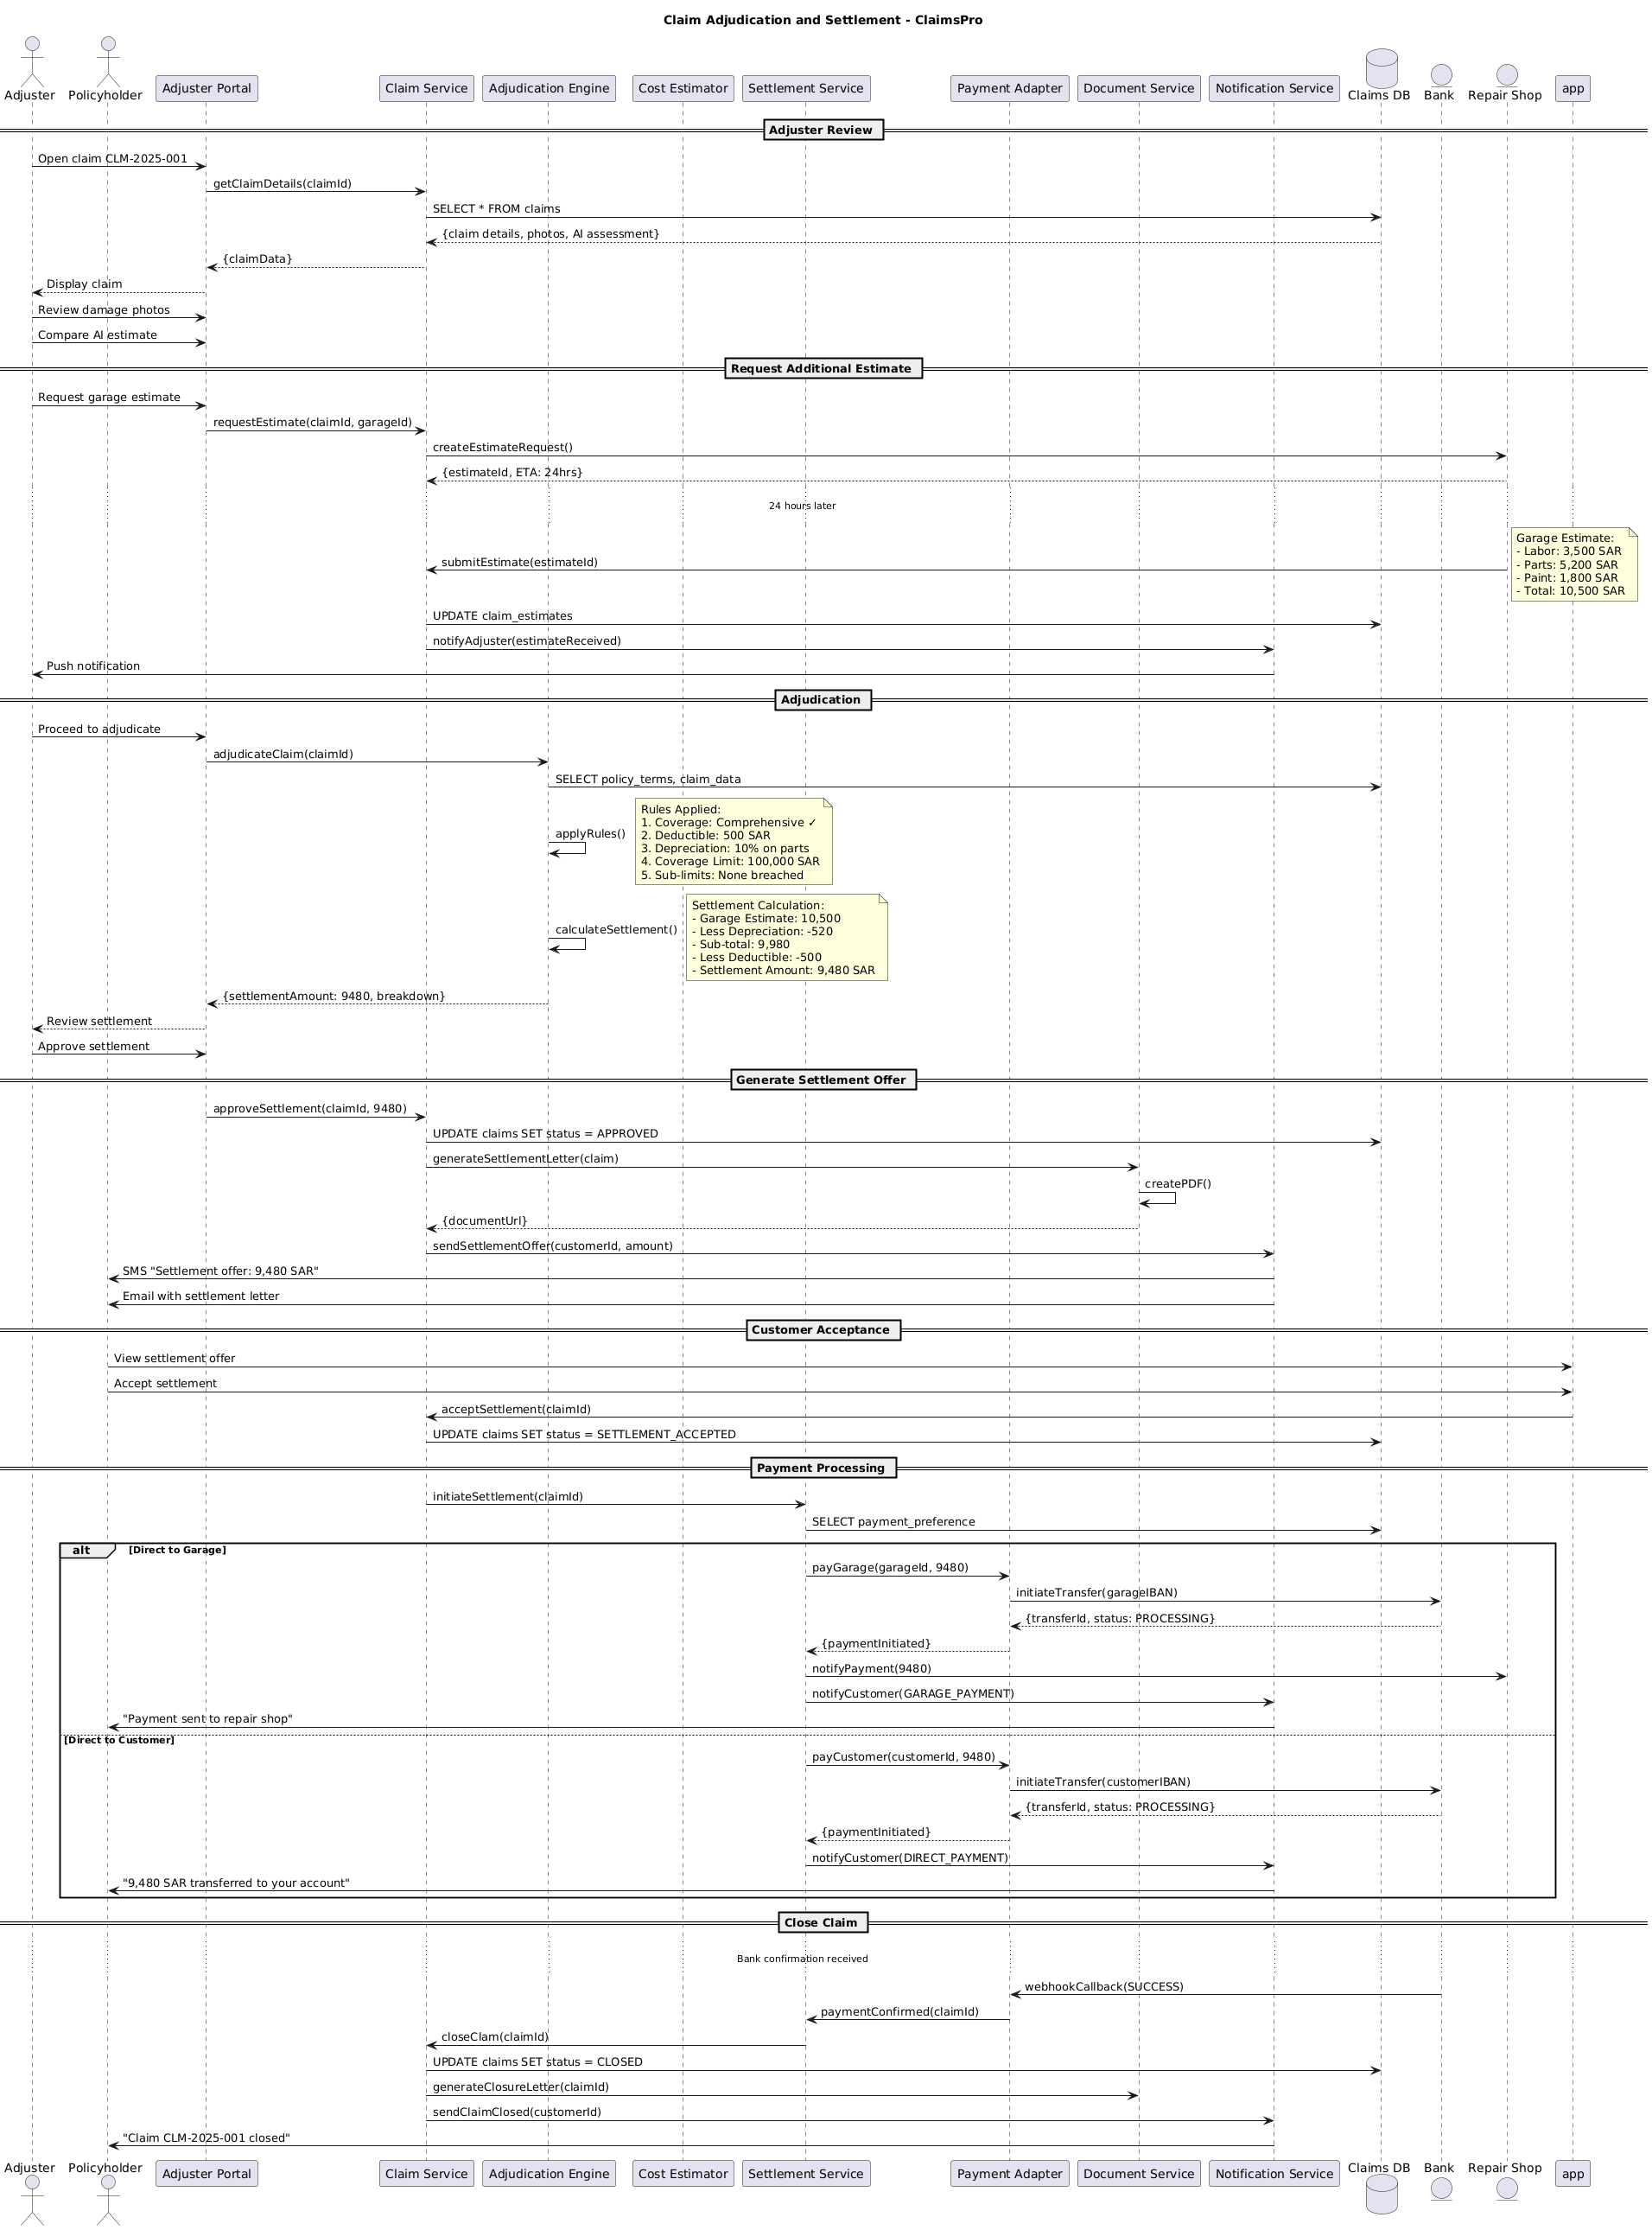

5.2. Flow Description
  - Overview
This flow describes the end-to-end claim adjudication and settlement process for the ClaimsPro platform. The process involves multiple actors and systems, including Adjuster, Policyholder, Adjuster Portal, Claim Service, Adjudication Engine, Cost Estimator, Settlement Service, Payment Adapter, Document Service, Notification Service, Claims DB, Bank, and Repair Shop. The flow covers claim review, estimate management, adjudication, settlement offer generation, customer acceptance, payment processing, and claim closure. Each step details the interactions, internal processing, and conditional logic required to complete a claim settlement.
  - Process Flow
Adjuster Review
The process begins when Adjuster opens claim CLM-2025-001 using Adjuster Portal. Adjuster Portal requests claim details from Claim Service. Claim Service queries Claims DB for all relevant information about the claim. Claims DB returns the claim details, associated photos, and any AI-generated assessment to Claim Service. Claim Service sends the aggregated claim data back to Adjuster Portal. Adjuster Portal presents the claim information to Adjuster for review.
Adjuster then reviews damage photos through Adjuster Portal. Adjuster also compares the AI-generated estimate using Adjuster Portal.
Request Additional Estimate
If further assessment is needed, Adjuster requests an additional estimate from a repair shop via Adjuster Portal. Adjuster Portal forwards this request to Claim Service, specifying the claim and the selected garage. Claim Service sends an estimate request to Repair Shop. Repair Shop responds to Claim Service with an estimate identifier and an expected turnaround time of 24 hours.
After 24 hours, Repair Shop submits the completed estimate to Claim Service.
Note: Garage Estimate:
- Labor: 3,500 SAR
- Parts: 5,200 SAR
- Paint: 1,800 SAR
- Total: 10,500 SAR
Claim Service updates the claim estimates in Claims DB. Claim Service notifies Notification Service that a new estimate has been received. Notification Service sends a push notification to Adjuster to inform them of the new garage estimate.
Adjudication
Once the additional estimate is available, Adjuster proceeds to adjudicate the claim using Adjuster Portal. Adjuster Portal initiates the adjudication process by sending the claim identifier to Adjudication Engine. Adjudication Engine retrieves the relevant policy terms and claim data from Claims DB. Adjudication Engine internally applies business rules to determine coverage and settlement eligibility.
Adjudication Engine performs an internal operation to calculate the settlement amount.
Note: Settlement Calculation:
- Garage Estimate: 10,500
- Less Depreciation: -520
- Sub-total: 9,980
- Less Deductible: -500
- Settlement Amount: 9,480 SAR
Adjudication Engine returns the calculated settlement amount and a breakdown to Adjuster Portal. Adjuster Portal presents the settlement details to Adjuster for review. Adjuster approves the settlement through Adjuster Portal.
Generate Settlement Offer
Adjuster Portal submits the settlement approval to Claim Service, including the claim identifier and the approved amount. Claim Service updates the claim status to APPROVED in Claims DB. Claim Service requests Document Service to generate a settlement letter for the claim. Document Service internally creates a PDF document. Document Service returns the URL of the generated document to Claim Service. Claim Service instructs Notification Service to send the settlement offer to the customer, including the settlement amount. Notification Service sends an SMS to Policyholder with the settlement offer details and also emails the settlement letter.
Customer Acceptance
Policyholder views the settlement offer using their application. Policyholder then accepts the settlement through the same application. The application notifies Claim Service of the acceptance, referencing the claim identifier. Claim Service updates the claim status to SETTLEMENT_ACCEPTED in Claims DB.
Payment Processing
Upon acceptance, Claim Service initiates the settlement process by contacting Settlement Service with the claim identifier. Settlement Service retrieves the payment preference from Claims DB.
If the payment preference is to pay the repair shop directly, Settlement Service instructs Payment Adapter to pay the garage the settlement amount. Payment Adapter initiates a transfer to the garage’s IBAN via Bank. Bank confirms that the transfer is processing and returns the transfer details to Payment Adapter. Payment Adapter informs Settlement Service that the payment has been initiated. Settlement Service notifies Repair Shop of the payment. Settlement Service also instructs Notification Service to notify the customer that payment was sent to the repair shop. Notification Service sends a message to Policyholder confirming payment to the repair shop.
Otherwise, if the payment preference is to pay the customer directly, Settlement Service instructs Payment Adapter to pay the customer the settlement amount. Payment Adapter initiates a transfer to the customer’s IBAN via Bank. Bank confirms that the transfer is processing and returns the transfer details to Payment Adapter. Payment Adapter informs Settlement Service that the payment has been initiated. Settlement Service instructs Notification Service to notify the customer of the direct payment. Notification Service sends a message to Policyholder confirming that 9,480 SAR was transferred to their account.
Close Claim
Once Bank confirms the payment via a webhook callback to Payment Adapter, Payment Adapter notifies Settlement Service that payment has been confirmed for the claim. Settlement Service instructs Claim Service to close the claim. Claim Service updates the claim status to CLOSED in Claims DB. Claim Service requests Document Service to generate a closure letter for the claim. Claim Service instructs Notification Service to send a claim closure notification to the customer. Notification Service sends a message to Policyholder confirming that claim CLM-2025-001 has been closed.
  - Authentication & Validation
Adjudication Engine internally applies rules to determine coverage, deductibles, depreciation, and sub-limits. Adjudication Engine performs an internal operation to calculate the settlement amount based on the applied rules and the garage estimate. Document Service internally creates a PDF document for the settlement letter.

5.3. State Machine Diagram
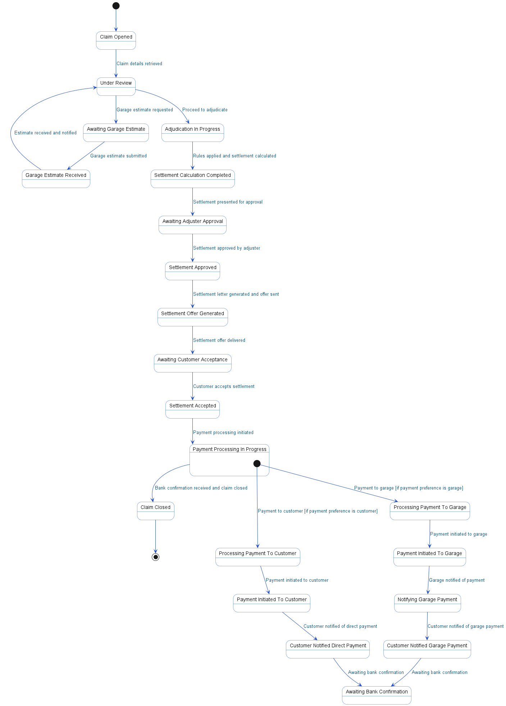

5.4. APIs Contract Agreement
# | Source | Destination | API | Protocol | Request Parameters | Response Parameters
1 | Adjuster Portal | Claim Service | getClaimDetails | REST | claimId | {claimData}
2 | Claim Service | Claims DB | SELECT * FROM claims | JDBC |  | {claim details, photos, AI assessment}
3 | Adjuster Portal | Claim Service | requestEstimate | REST | claimId, garageId
4 | Claim Service | Repair Shop | createEstimateRequest | REST |  | {estimateId, ETA: 24hrs}
5 | Repair Shop | Claim Service | submitEstimate | REST | estimateId
6 | Claim Service | Claims DB | UPDATE claim_estimates | JDBC
7 | Claim Service | Notification Service | notifyAdjuster | REST | estimateReceived
8 | Notification Service | Adjuster | Push notification | REST
9 | Adjuster Portal | Adjudication Engine | adjudicateClaim | REST | claimId | {settlementAmount: 9480, breakdown}
10 | Adjudication Engine | Claims DB | SELECT policy_terms, claim_data | JDBC
11 | Adjuster Portal | Claim Service | approveSettlement | REST | claimId, 9480
12 | Claim Service | Claims DB | UPDATE claims SET status = APPROVED | JDBC
13 | Claim Service | Document Service | generateSettlementLetter | REST | claim | {documentUrl}
14 | Claim Service | Notification Service | sendSettlementOffer | REST | customerId, amount
15 | Notification Service | Policyholder | SMS "Settlement offer: 9,480 SAR" | REST
16 | Notification Service | Policyholder | Email with settlement letter | REST
17 | app | Claim Service | acceptSettlement | REST | claimId
18 | Claim Service | Claims DB | UPDATE claims SET status = SETTLEMENT_ACCEPTED | JDBC
19 | Claim Service | Settlement Service | initiateSettlement | REST | claimId
20 | Settlement Service | Claims DB | SELECT payment_preference | JDBC
21 | Settlement Service | Payment Adapter | payGarage | REST | garageId, 9480 | {paymentInitiated}
22 | Payment Adapter | Bank | initiateTransfer | REST | garageIBAN | {transferId, status: PROCESSING}
23 | Settlement Service | Repair Shop | notifyPayment | REST | 9480
24 | Settlement Service | Notification Service | notifyCustomer | REST | GARAGE_PAYMENT
25 | Notification Service | Policyholder | "Payment sent to repair shop" | REST
26 | Settlement Service | Payment Adapter | payCustomer | REST | customerId, 9480 | {paymentInitiated}
27 | Payment Adapter | Bank | initiateTransfer | REST | customerIBAN | {transferId, status: PROCESSING}
28 | Settlement Service | Notification Service | notifyCustomer | REST | DIRECT_PAYMENT
29 | Notification Service | Policyholder | "9,480 SAR transferred to your account" | REST
30 | Bank | Payment Adapter | webhookCallback | REST | SUCCESS
31 | Payment Adapter | Settlement Service | paymentConfirmed | REST | claimId
32 | Settlement Service | Claim Service | closeClam | REST | claimId
33 | Claim Service | Claims DB | UPDATE claims SET status = CLOSED | JDBC
34 | Claim Service | Document Service | generateClosureLetter | REST | claimId
35 | Claim Service | Notification Service | sendClaimClosed | REST | customerId
36 | Notification Service | Policyholder | "Claim CLM-2025-001 closed" | REST
[*] Indicates that the data element is optional

5.5. Error Handling
# | Source | Destination | Scenario | Handling
1 | Adjuster Portal | Claim Service | getClaimDetails  Claim Service times out responding to claim details request | Retry up to 3 times with exponential backoff; Log error with correlation ID for traceability; Return error code to upstream caller
2 | Adjuster Portal | Claim Service | requestEstimate  Claim Service unavailable during estimate request | Retry up to 3 times with exponential backoff; Log error with correlation ID for traceability; Return error code to upstream caller
3 | Claim Service | Repair Shop | createEstimateRequest  Repair Shop service times out creating estimate request | Retry up to 3 times with exponential backoff; Log error with correlation ID for traceability; Return error code to upstream caller
4 | Repair Shop | Claim Service | submitEstimate  Claim Service unavailable when Repair Shop submits estimate | Retry up to 3 times with exponential backoff; Log error with correlation ID for traceability; Return error code to upstream caller
5 | Claim Service | Notification Service | notifyAdjuster  Notification Service unavailable when sending adjuster notification | Retry up to 3 times with exponential backoff; Log error with correlation ID for traceability; Queue request for asynchronous retry
6 | Adjuster Portal | Adjudication Engine | adjudicateClaim  Adjudication Engine times out during claim adjudication | Retry up to 3 times with exponential backoff; Log error with correlation ID for traceability; Return error code to upstream caller
7 | Claim Service | Document Service | generateSettlementLetter  Document Service unavailable during settlement letter generation | Retry up to 3 times with exponential backoff; Log error with correlation ID for traceability; Return error code to upstream caller
8 | Claim Service | Notification Service | sendSettlementOffer  Notification Service times out sending settlement offer | Retry up to 3 times with exponential backoff; Log error with correlation ID for traceability; Queue request for asynchronous retry
9 | Claim Service | Settlement Service | initiateSettlement  Settlement Service unavailable when initiating settlement | Retry up to 3 times with exponential backoff; Log error with correlation ID for traceability; Return error code to upstream caller
10 | Settlement Service | Payment Adapter | payGarage  Payment Adapter times out processing garage payment | Ensure idempotency to avoid duplicates on retry; Retry up to 3 times with exponential backoff; Log error with correlation ID for traceability; Queue request for asynchronous retry
11 | Settlement Service | Payment Adapter | payCustomer  Payment Adapter unavailable when processing customer payment | Ensure idempotency to avoid duplicates on retry; Retry up to 3 times with exponential backoff; Log error with correlation ID for traceability; Queue request for asynchronous retry
12 | Payment Adapter | Bank | initiateTransfer  Bank service times out initiating transfer | Ensure idempotency to avoid duplicates on retry; Retry up to 3 times with exponential backoff; Log error with correlation ID for traceability; Notify operations team via alert if repeated
13 | Settlement Service | Garage | notifyPayment  Garage service unavailable when notifying payment | Retry up to 3 times with exponential backoff; Log error with correlation ID for traceability; Queue request for asynchronous retry
14 | Settlement Service | Notification Service | notifyCustomer  Notification Service times out during customer notification | Retry up to 3 times with exponential backoff; Log error with correlation ID for traceability; Queue request for asynchronous retry
15 | Payment Adapter | Settlement Service | paymentConfirmed  Settlement Service unavailable when confirming payment | Retry up to 3 times with exponential backoff; Log error with correlation ID for traceability; Queue request for asynchronous retry
16 | Settlement Service | Claim Service | closeClam  Claim Service times out during claim closure | Ensure idempotency to avoid duplicates on retry; Retry up to 3 times with exponential backoff; Log error with correlation ID for traceability; Queue request for asynchronous retry
17 | Claim Service | Document Service | generateClosureLetter  Document Service unavailable generating closure letter | Retry up to 3 times with exponential backoff; Log error with correlation ID for traceability; Return error code to upstream caller
18 | Claim Service | Notification Service | sendClaimClosed  Notification Service times out sending claim closed notification | Retry up to 3 times with exponential backoff; Log error with correlation ID for traceability; Queue request for asynchronous retry

6. Appendix

6.1. Motor Insurance Claim Submission Data Elements
# | Service Name | Data Element | Description
1 | initiateFNOL (Request) | customerId | Customer Identification Code
2 | initiateFNOL (Response) | sessionId | Unique session identifier for FNOL process
3 | initiateFNOL (Response) | policies | List of customer’s active insurance policies
4 | getPolicies (Request) | customerId | Customer Identification Code
5 | getPolicies (Response) | motorPolicies | List of customer’s active motor insurance policies
6 | submitFNOL (Request) | policyId | Insurance policy identifier for the claim
7 | submitFNOL (Request) | vehicleId | Vehicle identifier involved in the incident
8 | submitFNOL (Request) | incidentDate | Date of the reported incident
9 | submitFNOL (Request) | description | Description of the incident by the customer
10 | submitFNOL (Request) | location | Incident location coordinates (latitude and longitude)
11 | submitFNOL (Request) | photos | Photos of the damaged vehicle taken by customer
12 | submitFNOL (Request) | policeReport | Uploaded police report document (optional)
13 | validateCoverage (Request) | policyId | Insurance policy identifier for validation
14 | validateCoverage (Request) | incidentDate | Date of the reported incident
15 | validateCoverage (Response) | valid | Indicates if policy is valid for the incident date
16 | validateCoverage (Response) | deductible | Deductible amount applicable for the claim
17 | validateCoverage (Response) | reason | Reason for invalid policy coverage
18 | analyzeDamage (Request) | photos | Photos of the damaged vehicle for AI assessment
19 | analyzeDamage (Response) | damageAssessment | AI-generated damage assessment details
20 | screenClaim (Request) | claimData | Data related to the submitted claim for fraud screening
21 | screenClaim (Response) | fraudScore | Numeric fraud risk score for the claim
22 | screenClaim (Response) | risk | Fraud risk level (LOW, MEDIUM, HIGH)
23 | screenClaim (Response) | flags | List of fraud flags or indicators detected
24 | createClaim (Request) | fnolData | First Notice of Loss data for claim creation
25 | createClaim (Request) | assessment | Damage assessment details for the claim
26 | createClaim (Response) | claimId | Unique identifier for the created claim
27 | initiateWorkflow (Request) | claimId | Unique identifier for the created claim
28 | initiateWorkflow (Response) | workflowId | Unique identifier for the workflow instance
29 | initiateWorkflow (Response) | assignedTo | Identifier of the adjuster assigned to the claim
30 | sendClaimConfirmation (Request) | claim | Claim object containing claim details for notification
31 | notifyAdjuster (Request) | ADJ-005 | Identifier of the assigned adjuster
32 | claim (Response) | claimId | Unique identifier for the created claim
33 | claim (Response) | status | Current transaction status

6.2. Claim Adjudication and Settlement Data Elements
# | Service Name | Data Element | Description
1 | getClaimDetails (Request) | claimId | Unique identifier for the insurance claim
2 | getClaimDetails (Response) | claimData | Detailed information about the insurance claim
3 | requestEstimate (Request) | claimId | Unique identifier for the insurance claim
4 | requestEstimate (Request) | garageId | Unique identifier for the repair shop
5 | createEstimateRequest (Response) | estimateId | Unique identifier for the garage estimate request
6 | createEstimateRequest (Response) | ETA | Estimated time for estimate completion (e.g., 24hrs)
7 | submitEstimate (Response) | Labor | Estimated labor cost for repairs
8 | submitEstimate (Response) | Parts | Estimated parts cost for repairs
9 | submitEstimate (Response) | Paint | Estimated paint cost for repairs
10 | submitEstimate (Response) | Total | Total estimated cost for repairs
11 | adjudicateClaim (Request) | claimId | Unique identifier for the insurance claim
12 | adjudicateClaim (Response) | settlementAmount | Final settlement amount to be paid
13 | adjudicateClaim (Response) | breakdown | Breakdown of settlement calculation components
14 | approveSettlement (Request) | claimId | Unique identifier for the insurance claim
15 | approveSettlement (Request) | 9480 | Approved settlement amount (in SAR)
16 | generateSettlementLetter (Request) | claim | Claim data used to generate settlement letter
17 | generateSettlementLetter (Response) | documentUrl | URL link to the generated settlement letter document
18 | sendSettlementOffer (Request) | customerId | Unique identifier for the policyholder
19 | sendSettlementOffer (Request) | amount | Settlement offer amount sent to customer
20 | acceptSettlement (Request) | claimId | Unique identifier for the insurance claim
21 | initiateSettlement (Request) | claimId | Unique identifier for the insurance claim
22 | payGarage (Request) | garageId | Unique identifier for the repair shop
23 | payGarage (Request) | 9480 | Settlement amount to be paid to garage (in SAR)
24 | initiateTransfer (Request)  initiateTransfer (Response)  payCustomer (Request) | garageIBAN | International Bank Account Number of the repair shop
25 |  | transferId | Unique identifier for the bank transfer
26 |  | status | Current transaction status of the transfer
27 |  | customerId | Unique identifier for the policyholder
28 |  | 9480 | Settlement amount to be paid to customer (in SAR)
29 |  | customerIBAN | International Bank Account Number of the customer
30 | webhookCallback (Request) | SUCCESS | Status indicating successful payment confirmation
31 | paymentConfirmed (Request) | claimId | Unique identifier for the insurance claim
32 | closeClam (Request) | claimId | Unique identifier for the insurance claim
33 | generateClosureLetter (Request) | claimId | Unique identifier for the insurance claim
34 | sendClaimClosed (Request) | customerId | Unique identifier for the policyholder

6.3. Solution Architecture Reference Documents
# | Name | File
1 | BRD | Refer to Latest BRD Attached to JIRA Ticket

